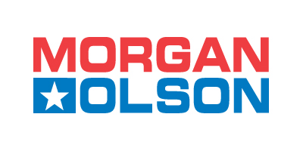
To:_____________________

From:___________________
1801 S. NOTTAWA STREET
STURGIS, MI 49091
ATTN:
PHONE:
Service Parts FAX: (269) 659-0499

Trucks FAX: (269) 659-0430

CREDIT APPLICATION
A FINANCIAL STATEMENT must accompany this form to expedite prompt and complete consideration for credit approval. All information furnished is for the confidential use of the Credit Dept. ONLY.
Application Date:__________________________________ Date Business Established:_________________________________________
Company Name:__________________________________________________________________________________________________
Address:________________________________________________________________________________________________________
(STREET) (CITY) (STATE) (ZIP)

Phone:________________________________________________Fax:______________________________________________________
Tax Exempt Number:______________________________________ Resale Certificate:_______________________________________
Type of Ownership: ______Proprietorship ______Partnership ______Corporation
Credit line Requesting: _$_________________ Does your company require a purchase order number with each purchase? ______YES ______NO
Accounts Payable Contact: _______________________________________________________________________________________
Name, Title, and Address of Principals (If Corporation, List Officers):
1.______________________________________________________________________________________________________________
2.______________________________________________________________________________________________________________
3.______________________________________________________________________________________________________________
Bank References (Name and Address)
1.______________________________________________________________________________________________________________
2.______________________________________________________________________________________________________________

Trade References
1.______________________________________________________________________________________________________________
(NAME) (ADDRESS) (CITY) (STATE) (ZIP)
______________________________________________________________________________________________________________
(PHONE) (FAX)
2.______________________________________________________________________________________________________________
(NAME) (ADDRESS) (CITY) (STATE) (ZIP)
______________________________________________________________________________________________________________
(PHONE) (FAX)
3.______________________________________________________________________________________________________________
(NAME) (ADDRESS) (CITY) (STATE) (ZIP)
______________________________________________________________________________________________________________
(PHONE) (FAX)

Statements and representations made herein are for the sole purpose of establishing credit with Morgan Olson LLC for the purchase by the applicant of vehicles or truck parts.

(Signature, Title, and Date)
PLEASE NOTE: IF WE DO NOT RECEIVE A COPY OF YOUR RESALE CERTIFICATE OR USE TAX EXEMPTION CERTIFICATE, THEN WE MUST CHARGE TAX ON YOUR INVOICES. THANK YOU.

